Chapter 3: Methodology

3.0 Introduction
This chapter presents the methodology adopted in the study, outlining the systematic procedures used to design, implement, and evaluate the proposed explainable AI model for pulmonary edema detection in chest X-ray images. The methodology ensures that the research is conducted in a structured, transparent, and reproducible manner. It covers the system design, components and requirements, data collection, preprocessing, model development, testing, and evaluation. The approach emphasizes both accuracy and interpretability, aligning with the clinical relevance of the study and the resource constraints of the local environment.
3.1 Methodological Approach

Figure 1: Agile Methodology Approach
PHASE DESCRIPTION
PHASE | DESCRIPTION
Data Collection | Chest X-ray images were obtained from Mbeya Regional Hospital.
Preprocessing | Images were resized, normalized, and augmented to improve quality and diversity.
Model Training | A Convolutional Neural Network (CNN) was trained to classify X-ray images.
Evaluation | Performance was assessed using accuracy, sensitivity, specificity, and AUC metrics.
Explainability | Visualization techniques such as Grad-CAM were applied to interpret model decisions.
Figure 2: Phase Methodology description

3.2 Research Design Overview
The proposed Explainable AI Model for Pulmonary Edema Detection in Chest X-ray Images has four parts that work together. These parts are the data acquisition and preparation unit the AI model development and training module, the explainability and visualization component and the evaluation and validation framework. The Explainable AI Model for Pulmonary Edema Detection in Chest X-ray Images uses these parts to achieve its goals. The data acquisition and preparation unit and the AI model development and training module are parts of the Explainable AI Model for Pulmonary Edema Detection in Chest X-ray Images. The explainability and visualization component and the evaluation and validation framework also play a role in the Explainable AI Model for Pulmonary Edema Detection, in Chest X-ray Images.
3.2.1 Working Principle of the Research Design
The research design is guided by the principle of applying explainable artificial intelligence (XAI) to medical imaging for clinical decision support. Pulmonary edema detection relies on identifying radiographic features in chest X-rays, which are systematically analyzed using convolutional neural networks (CNNs). The design ensures that the study is both descriptive and experimental: descriptive in documenting the dataset and its characteristics, and experimental in testing the AI model’s performance under controlled conditions. Ethical considerations and reproducibility are embedded throughout the design to align with academic and clinical standards.

3.2.2 Proposed Research Design
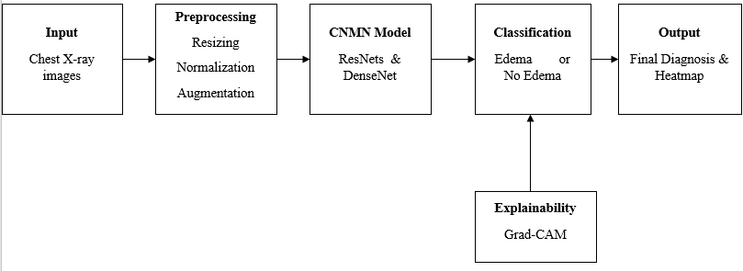
Figure 3: Block diagram of the proposed system (source: own)
3.3 Tools and Technology Approach
In order to successfully implement the pulmonary edema detection system, several tools and technologies were employed. These tools provided the necessary environment for data handling, model development, evaluation, and visualization.
- Programming Language.
- Python was chosen due to its flexibility, extensive libraries for machine learning, and strong community support. It enabled efficient data preprocessing, model training, and integration of explainability techniques.
- Framework and Libraries.
- TensorFlow & Keras: Used for building and training the Convolutional Neural Network (CNN).
- OpenCV: Applied for image preprocessing tasks such as resizing and normalization.
- Matplotlib & Seaborn: Utilized for graphical analysis and visualization of results.
- Grad-CAM: Implemented to generate heatmaps for explainability of model predictions.
- Hardware Environment.
- Laptop.
- Dataset Source.
- Mbeya Regional Hospital: Provided chest X-ray images categorized into pulmonary edema and normal cases.
- Public Medical Archives: Supplementary data was included to enhance model validation and reliability.
3.4 Data Collection Methods
3.4.1 Data Collection
The data collection process for this study was designed to obtain high-quality chest X-ray images representing both pulmonary edema and non-edema cases. The dataset was sourced from Mbeya Regional Hospital, where anonymized patient records were used under ethical approval from the institution. Additional publicly available datasets were referenced to supplement local data and ensure model generalization.
The data collection involved collaboration with medical personnel to identify relevant cases and verify diagnostic labels. Each image was reviewed to confirm clarity, resolution, and diagnostic accuracy before inclusion in the dataset. The collected data were stored securely and organized into two categories: positive (edema) and negative (no edema) samples.
The dataset was then prepared for analysis through preprocessing steps such as resizing, normalization, and augmentation to enhance image quality and balance the dataset distribution. These steps ensured that the AI model could learn effectively from diverse and representative samples.
3.4.2 Datasets Description
The dataset used in this research consists of chest X-ray images categorized by diagnostic outcomes. Each image includes metadata such as patient age, gender, and clinical notes (where available). The dataset is structured as follows:
Table 1: Chest X-ray images Datasets
Category | Number of Images | Source | Description
Pulmonary Edema | 40 | Mbeya Regional Hospital | X-ray images showing fluid accumulation in lungs
No Edema | 40 | Mbeya Regional Hospital | Normal chest X-ray images without edema
Supplementary Data | 20 | Public Medical Archives | Additional samples for model validation

All images were standardized to a uniform resolution of 224 × 224 pixels and converted to grayscale for consistency. Preprocessing steps such as normalization and augmentation were applied to improve image quality and balance the dataset distribution, ensuring effective training and validation of the AI model.
3.5 Data Processing and Analysis
3.5.1 Data Processing and Analysis Techniques
The collected chest X-ray images were subjected to a series of preprocessing steps to ensure consistency, reliability, and suitability for deep learning analysis. The preprocessing involved resizing all images to a uniform resolution of 224 × 224 pixels, converting them to grayscale to reduce computational complexity, and applying normalization to standardize pixel intensity values. Data augmentation techniques such as rotation, flipping, and contrast adjustment were employed to increase dataset diversity and minimize overfitting.
After preprocessing, the dataset was split into training, validation, and testing subsets to facilitate model development and evaluation. Convolutional Neural Network (CNN) architectures, specifically ResNet and DenseNet, were trained on the processed data to automatically extract radiographic features and classify images into pulmonary edema or non-edema categories. To enhance clinical trust, explainable AI methods such as Grad-CAM were integrated, enabling visualization of the regions within the X-ray images that contributed most to the model’s decision.
3.5.2 Performance and Evaluation of the model.

Figure 4: Chest X-ray images Datasets Distribution

3.5.3 Flow Chart of the System
The workflow of the system begins with data collection from Mbeya Regional Hospital and public archives, followed by preprocessing and normalization. The processed dataset is then used to train CNN models with cross-validation to ensure robustness and generalization. The trained model performs classification of chest X-rays into edema or non-edema categories, while Grad-CAM provides heatmap visualizations for interpretability. The results are presented as diagnostic outputs that combine accuracy metrics with visual explanations, supporting clinical decision-making.

End
Diagnosis & Report
Performance Evaluation
GRAD-CAM
NoEdema
Edema
Start
Data Collection
Data Preprocessing
Data Splitting
CNN Model training

